Library2go

Oregon Digital Library Consortium

Did you know the Oregon Digital Library Consortium has thousands of eBooks and audiobooks? You can borrow them, instantly--for free--using just the device in your hand!

Download eBooks, eAudiobooks, & videos to your home computer, mp3 player and many other mobile devices.

Getting started with the Libby app

- Initial Set-up
Find and open your library’s digital collection by going to your app store and downloading the following free Libby app. It looks like this!
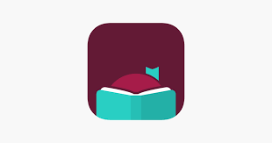

- Select: Yes, I Have A Library Card
- Select: Search For A Library
- Enter the zip code for your Home Library (Arlington is 97812)
- Select: Oregon Digital Library Consortium
- Select: Sign In With My Card
- Scroll through the library list and select: LEO Listens - Libraries of Eastern Oregon
- Enter your full library card number (14 digits, no spaces)
- Click Next
- If you know your PIN, enter it (It’s most likely the last four digits of your primary phone #)
  - If you don’t know your 4 digit PIN, call the library at 541-705-2555
- Click Sign in
- If successful, you will see a digital image of your library card and number
- Click Next

- Search & Borrow
  - Use the filters and search for… whatever you like!
    - Books, AudioBooks, Magazines
  - Place Holds, Read Samples, Save to read later, Borrow

- Enjoy
You can enjoy many titles immediately online, download them for offline use, or send borrowed eBooks to a Kindle device. If you’re on a computer, you may also be able to transfer titles to compatible eReaders or MP3 players.
If you need assistance within the app, click the icon with the 3 bars in the center of the menu bar and scroll down to Help & Support.

